

Mathematics Specialist
Unit 3
2017
TEST 4: Differentiation and Integration

Student name: _______________________ Teacher name: _______________________

SOLUTIONS

Time allowed for this task: 45 minutes, in class, under test conditions
Calculator-Assumed

Materials required:
Standard items: Pens (blue/black preferred), pencils (including coloured), sharpener, correction fluid/tape, eraser, ruler, highlighters, SCSA Formula Sheet.
Classpad Calculator and Scientific Calculator.
Special items: Drawing instruments, templates

Marks available: 44 marks

Task weighting: 8%

Question 1 (6 marks)
Determine $\frac{dy}{dx}$ for each of the following:

$y=\log_{5}(x^{2}+9)$ (3 marks)

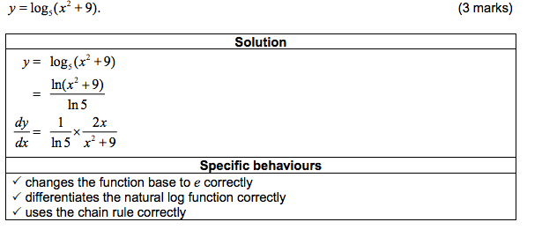

(b) $x=e^{sint}$ and $y=e^{cost}$ simplifying in terms of $t$ (3marks)

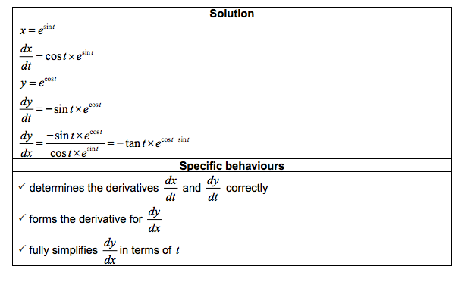

Question 2 (7 marks)

Evaluate exactly:

(a) $\int_{0 }^{1}{\frac{1-x}{ x+1}} dx (Hint: let u=x+1$) (4 marks)

(b) $\int_{0}^{\frac{1}{4}}{\cos^{2}}\left(πx\right)dx$ (3 marks)
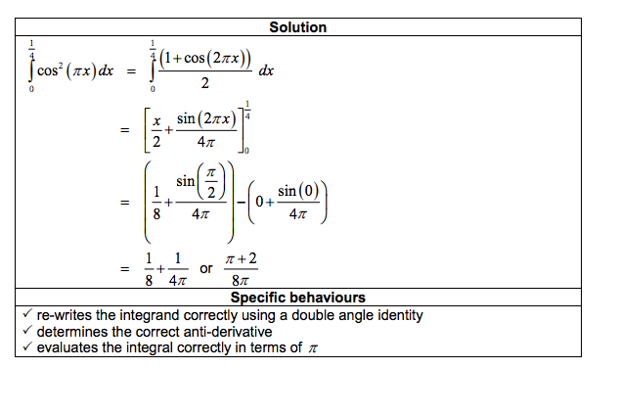

Question 3 (4 marks)

Use the substitution 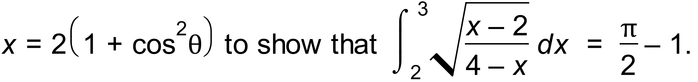

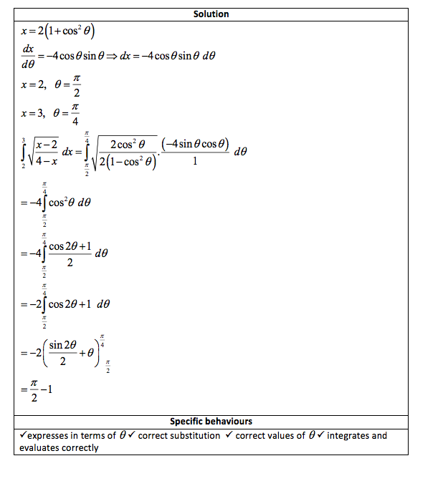

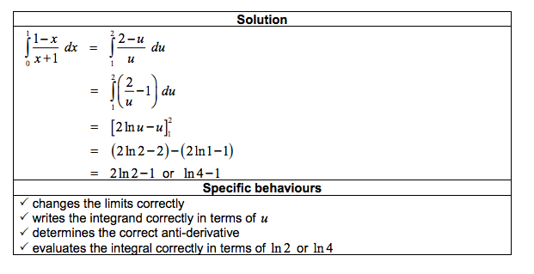
Question 4 (3 marks)

(a) Find the equation of the tangent to the curve at the point (1, -2).
(3 marks)

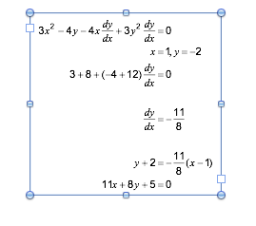

Question 5 (4 marks)
(a) Using partial fractions, or otherwise, determine $\int{\frac{x-19}{(x+1)(x-4)}}dx$.

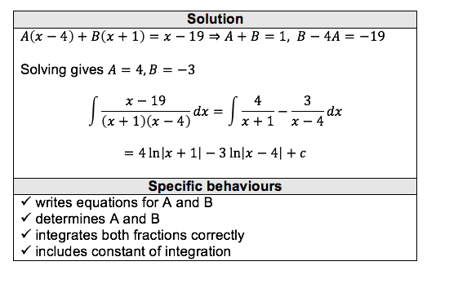

Calc assumed

Question 6 (7 marks)
The graph of $y=f(x)$ is shown below, where $f\left(x\right)={4cos}^{4}{(2x)}$ and A is the smallest root of $f\left(x\right), x>0$.

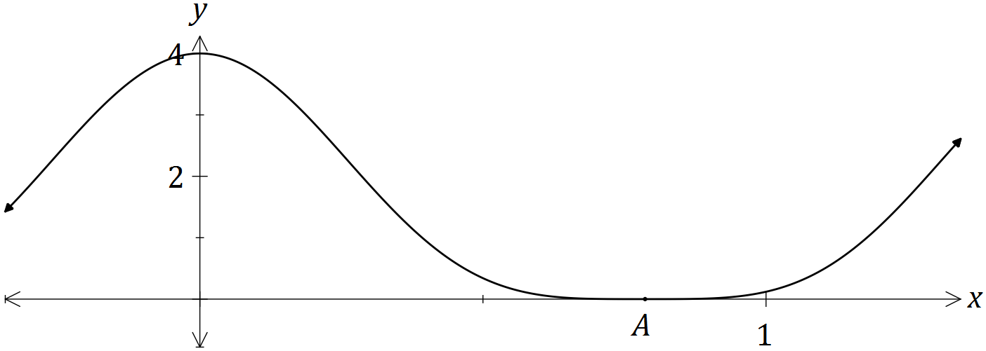

(a) Show that ${4cos}^{4}{(2x)}=\frac{3+4\cos{(4x)}+\cos{(8x)}}{2}$. (3 marks)
Solution
$$4\cos^{4}\left(2x\right)={{4(cos}^{2}{(2x))}}^{2} \\ ={4\left(\frac{1+\cos{4x}}{2}\right)}^{2} \\ =1+2\cos{4x}+\cos^{2}{4x} \\ =1+2\cos{4x}+\frac{1+\cos{8x}}{2} \\ =\frac{3+4\cos{(4x)}+\cos{(8x)}}{2}$$

Specific behaviours
uses double angle identity
expands and uses identity again
simplifies as required

(b) Hence determine $\int{{4cos}^{4}{(2x)}}dx$. (2 marks)

Solution
$$\int{\frac{3+4\cos{(4x)}+\cos{(8x)}}{2}}dx=\frac{3x}{2}+\frac{1}{2}\sin{4x}+\frac{1}{16}\sin{8x}+c$$

Specific behaviours
uses result from (a) to integrate
obtains correct result, including constant

(c) Determine the exact volume of the solid generated when the region bounded by $=f\left(x\right),$ $y=0$, $x=0$ and $x=A$ is rotated through 360° about the x-axis.
(2 marks)
Solution
$\int_{0}^{\frac{π}{4}}{π}{\left(4\cos^{4}\left(2x\right)\right)}^{2}dx=\frac{35π^{2}}{32}$ cubic units

Specific behaviours
writes integral
evaluates integral in exact form

Question 7 (5 marks)

A four-metre-long water tank, open at the top, is in the shape of a triangular prism. The triangular face is a right isosceles triangle with congruent sides of one metre length.

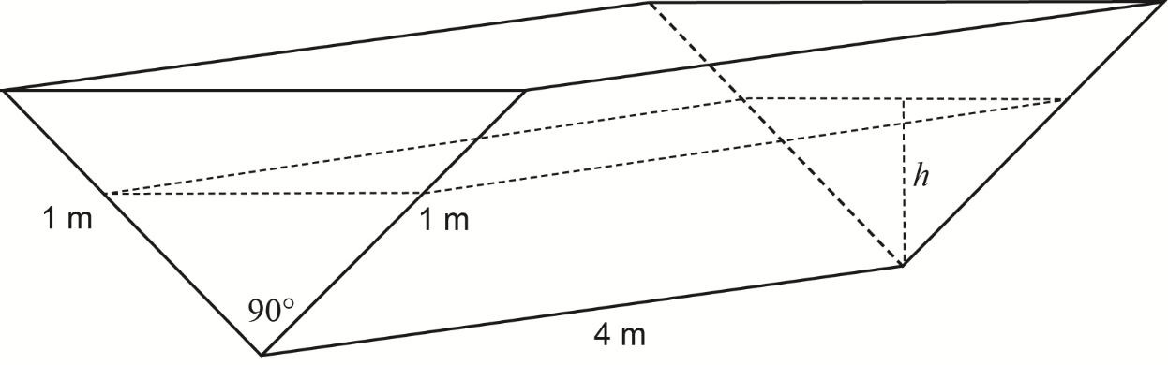

Initially the tank is completely full with water, but it develops a leak and loses water at a constant rate of 0.08 cubic metres per hour.
Let h = the depth of water, in metres, in the tank after t hours.
(a) Show that the volume of water in the tank V cubic metres, is given by the expression
$V\left(h\right)=4h^{2}.$ (2 marks)

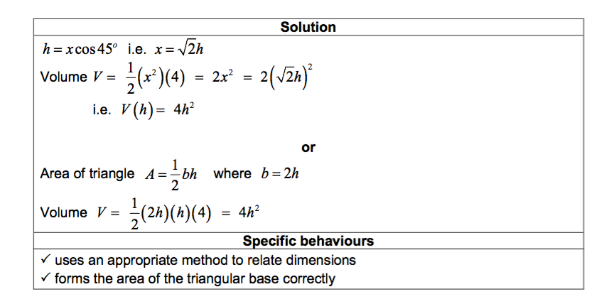

(b) Determine the rate of change of the depth, correct to the nearest 0.01 metres per hour,
when the depth is 0.6 metres. (3 marks)
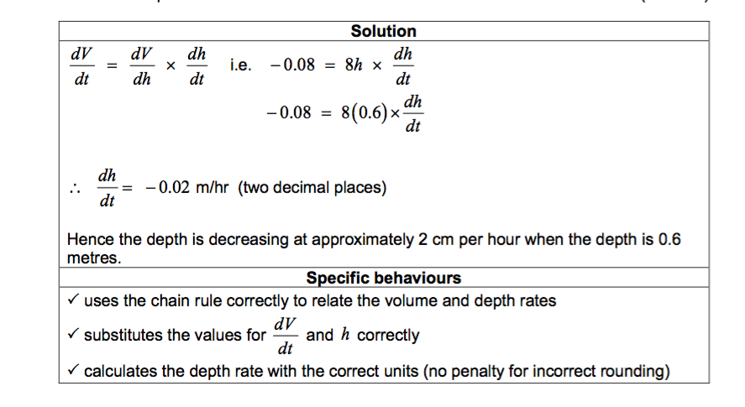

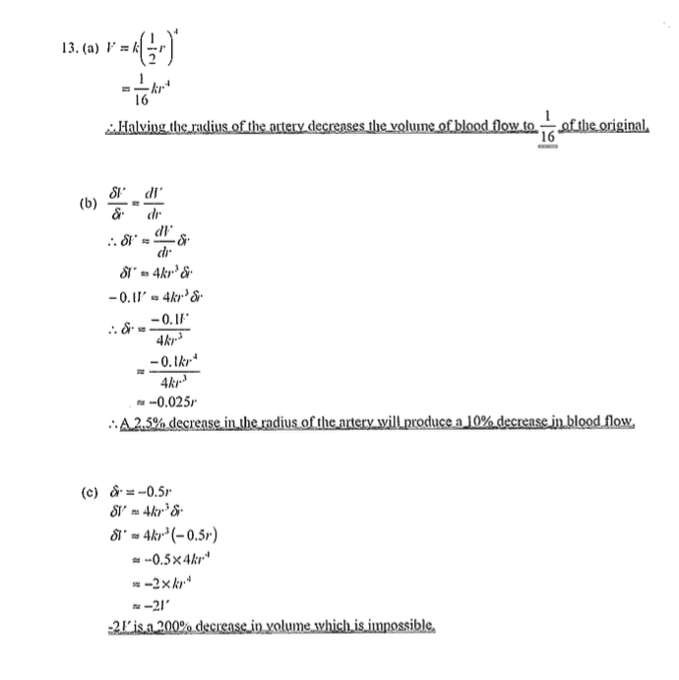
Question 8 (10 marks)

(2 marks)

(5marks)

(3 marks)

